Project Report

Spherical K-Means

Name: Revanth Kalluri
Course: AI & ML (Batch-5)
Problem Statement: Implement Spherical K-Means to cluster artificial dataset.

Prerequisites:
Software used and how I installed them:
Python 3.6: Download and install anaconda using https://www.anaconda.com/download/. After installing anaconda, install below modules(packages), using anaconda prompt to run the commands.
Module | Command
numpy | pip install numpy
sklearn | pip install scikit-learn
matplotlib | pip install matplotlib
pandas | pip install pandas

Pip is a package manager for python packages. Run “pip --version” in anaconda prompt to verify if pip is already installed. Run “conda install pip” to install pip for the first time.

Dataset used:
The dataset is synthetically generated using sklearn.datasets.make_blobs

Method used:
Spherical K-Means.

1. Importing necessary modules:
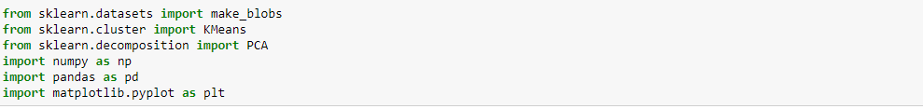
2. Generate dummy dataset:
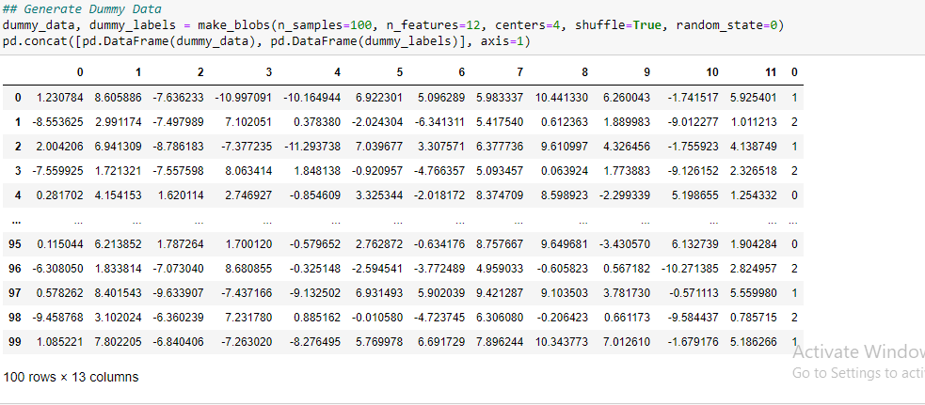
3. Apply K-Means:
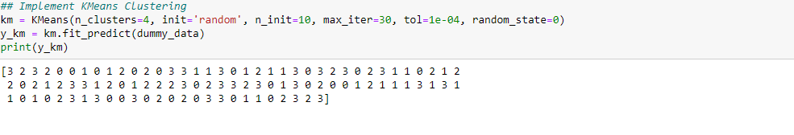
4. Randomly initialize labels and define function for cosine similarity:
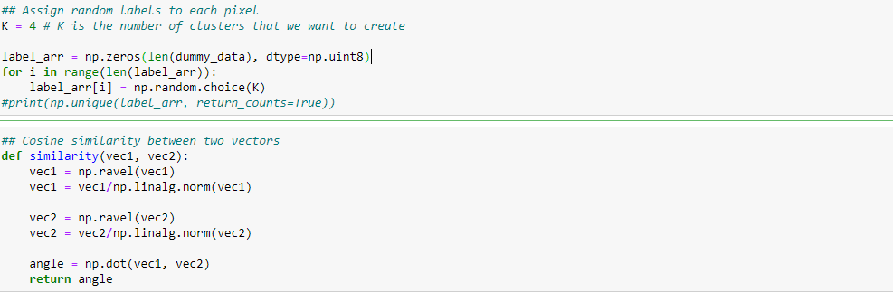

5. Define functions for mean and label updates:
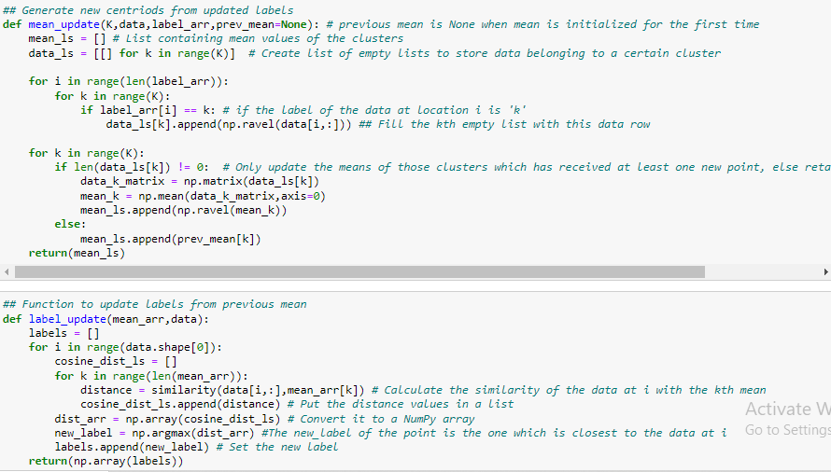
6. Define Spherical K-means Algorithm:
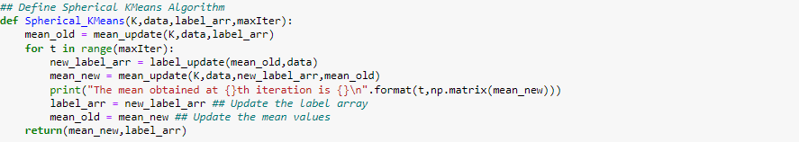

7. Implement Spherical K-Means:
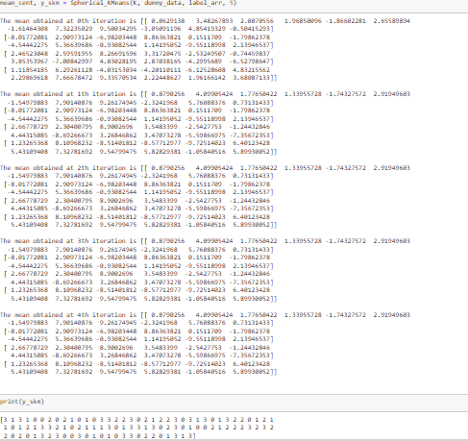

8. Plot the data using labels obtained from both K-Means and Spherical K-Means:
